**Bamazon workflow:**

**Department table:**

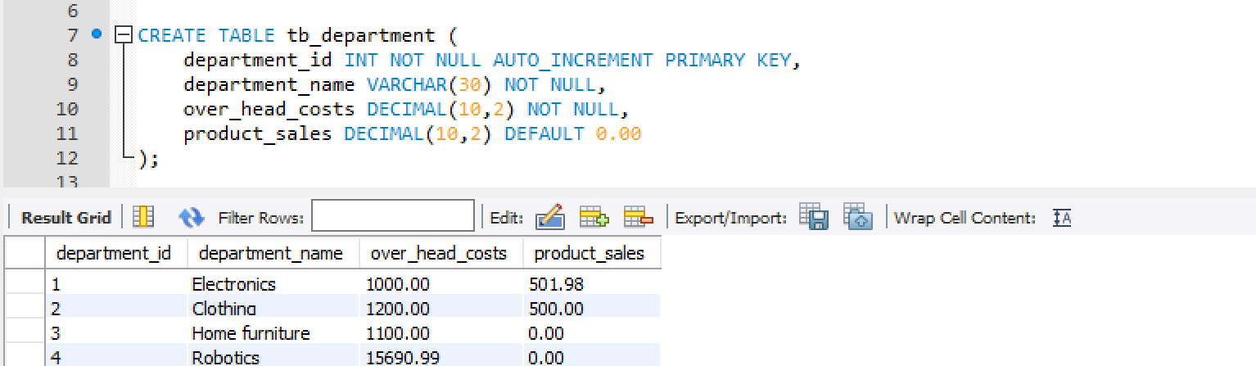

**Product table:**

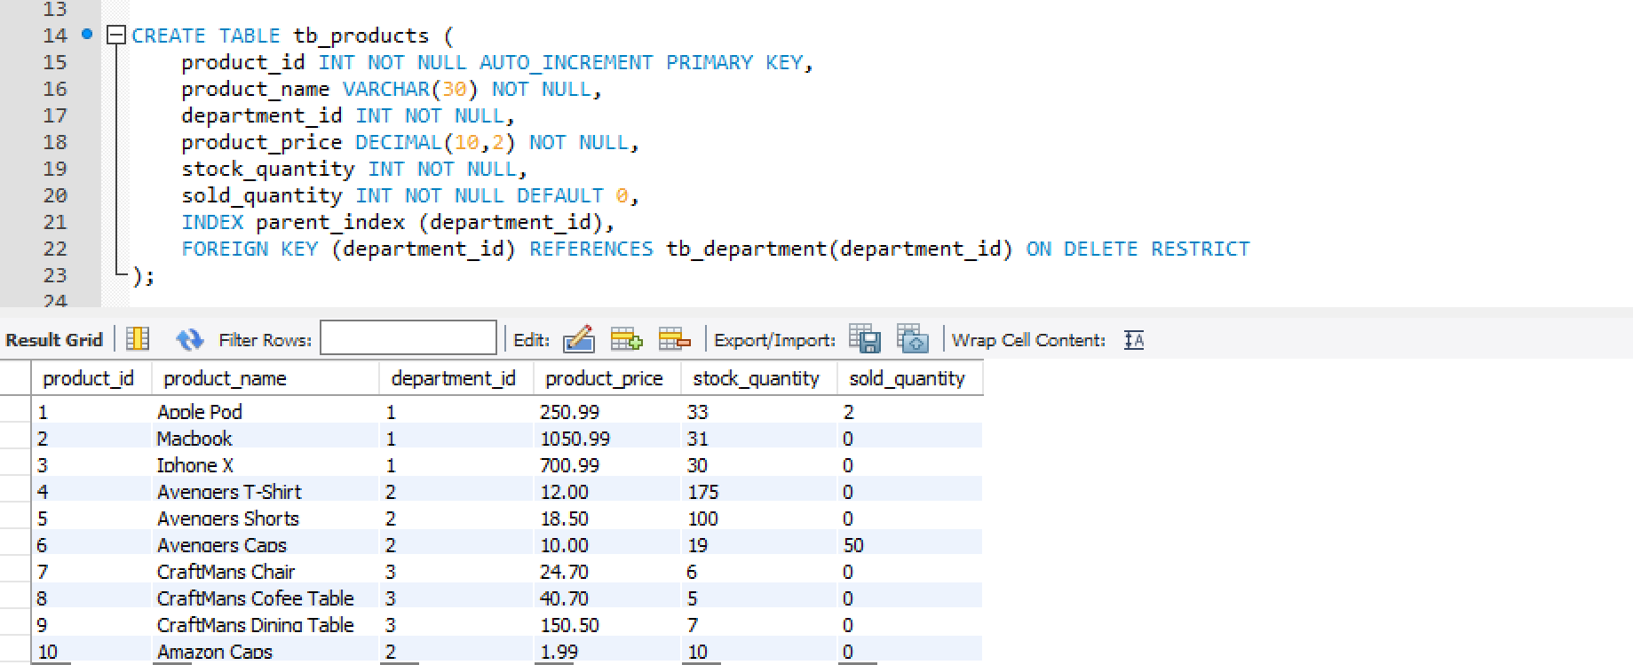

Customer View:

1. On running bamazoncustomer.js , lists all available products & asks product to buy

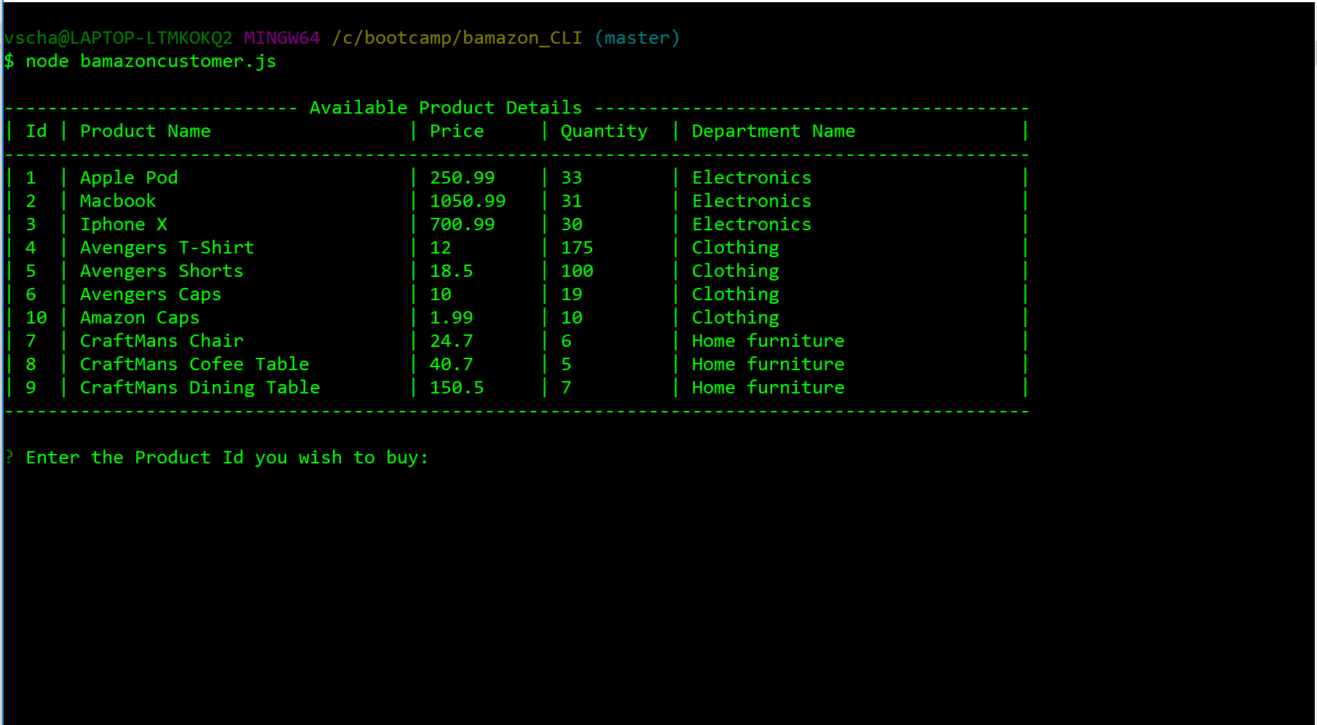

B. choose invalid product ID (not inlist/ non-numeric) , it shows invalid product & asks user to enter again

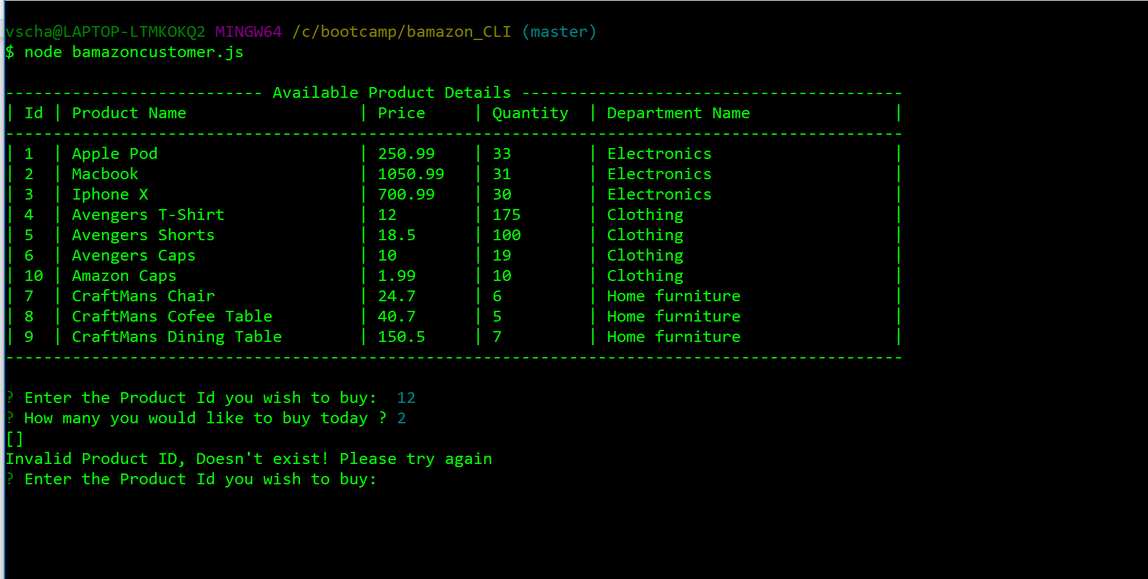

C. Enter valid information: It will show success message & decreases the quantity & also adds the total sales amount to respective department table.

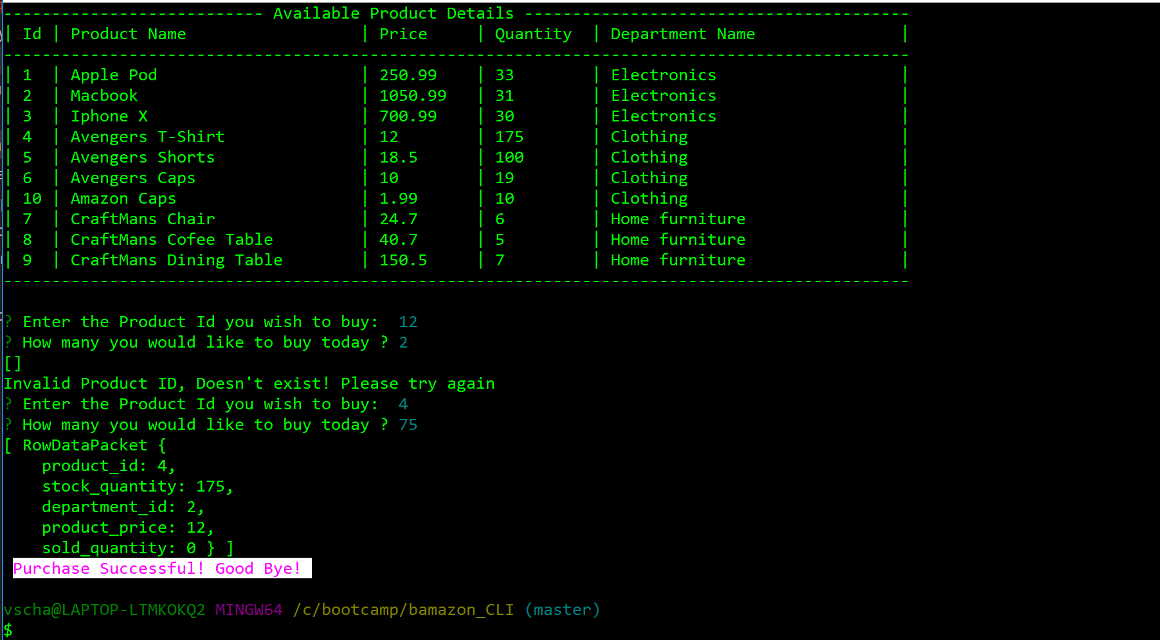

After above transaction new tables looks like below (product table- product_id #4, 75 stock reduced and sold increased) & sales table - for dept_id#2 increased by 75*12

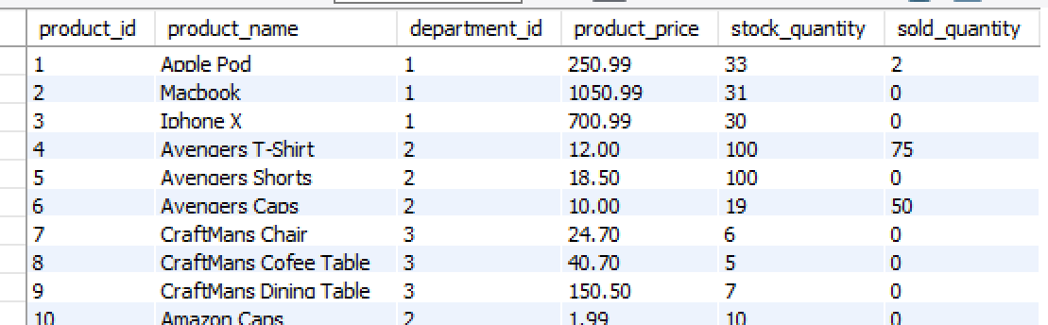

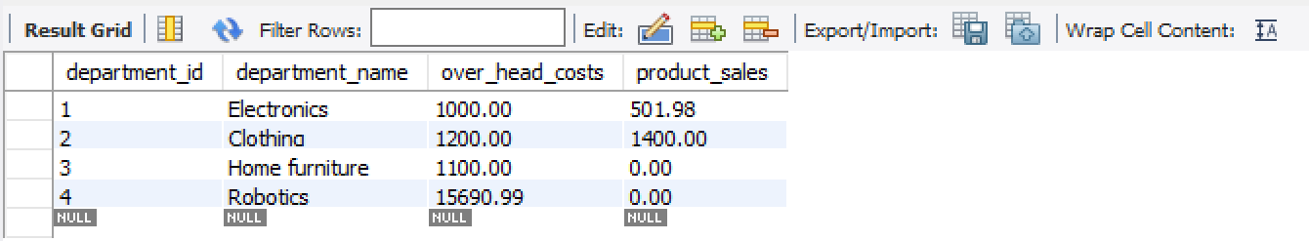

Manager view :

-> On running bamazonmanager.js, shows various options

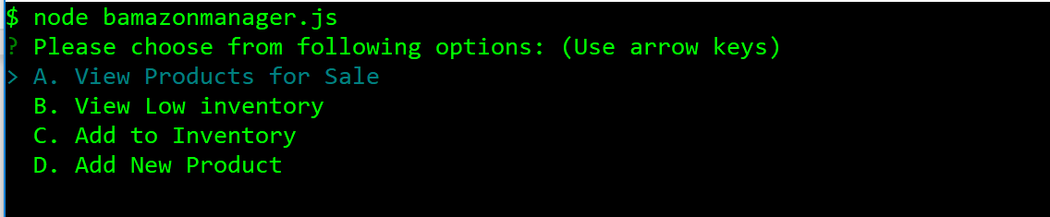

-> on selecting option.A, view products for same ( it also shows number of sold column for manager)

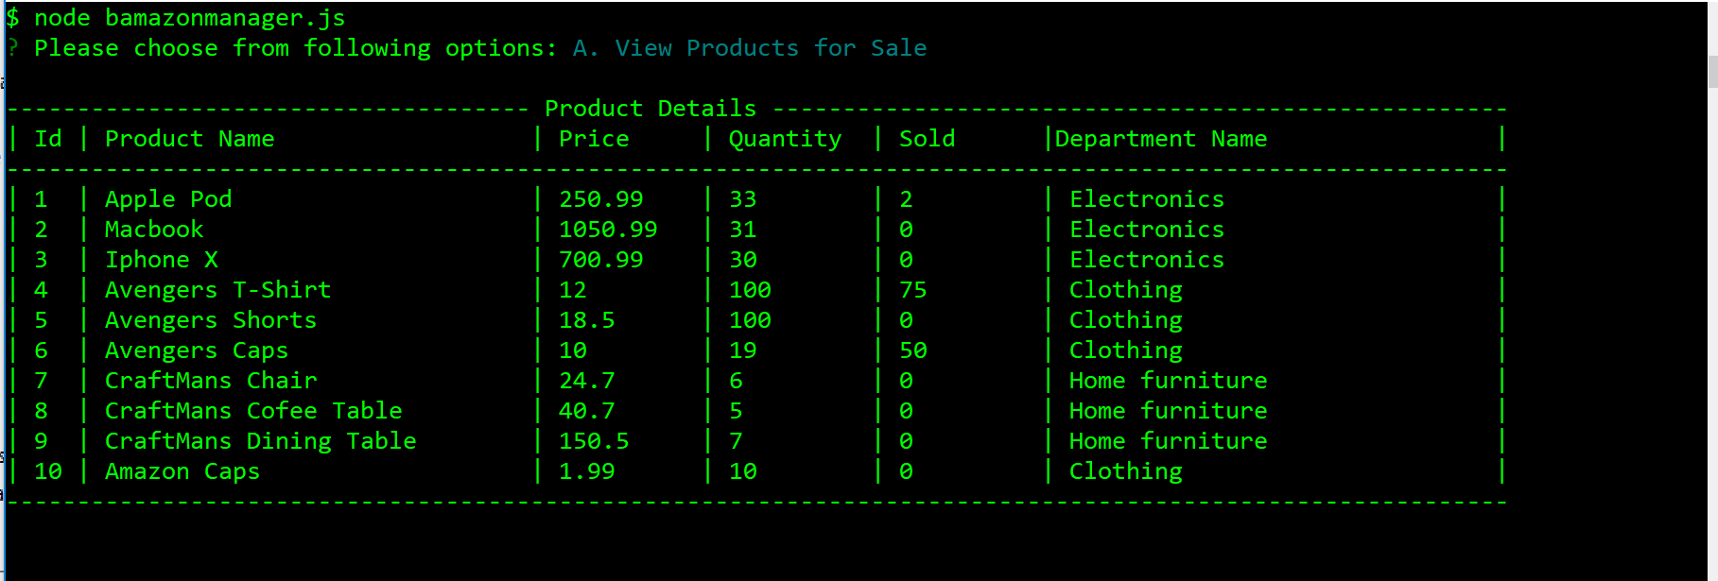

-> on selecting option.B, shows low inventory less or equal to 5

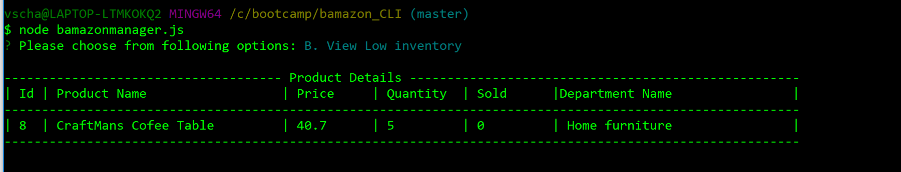

-> on selecting option.C, we can add quantity to existing products (add inventory) - In below example product_Id #10 added with 10 more.

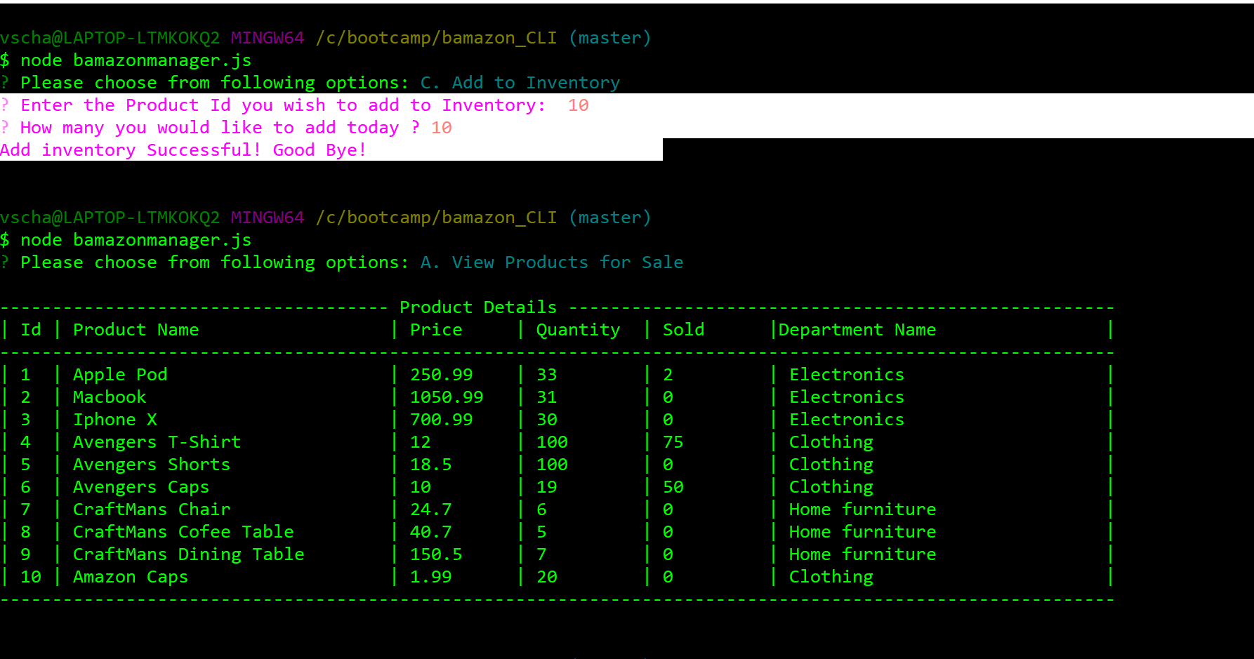

-> on selecting option.D , we can add new product. In below sample , I added new product “Google Phone” with Quantity as 5 with proce of 760.99 under department_id#1 (electronics), auto incremented to #12 ( I guess 11 was earlier created and deleted during testing)

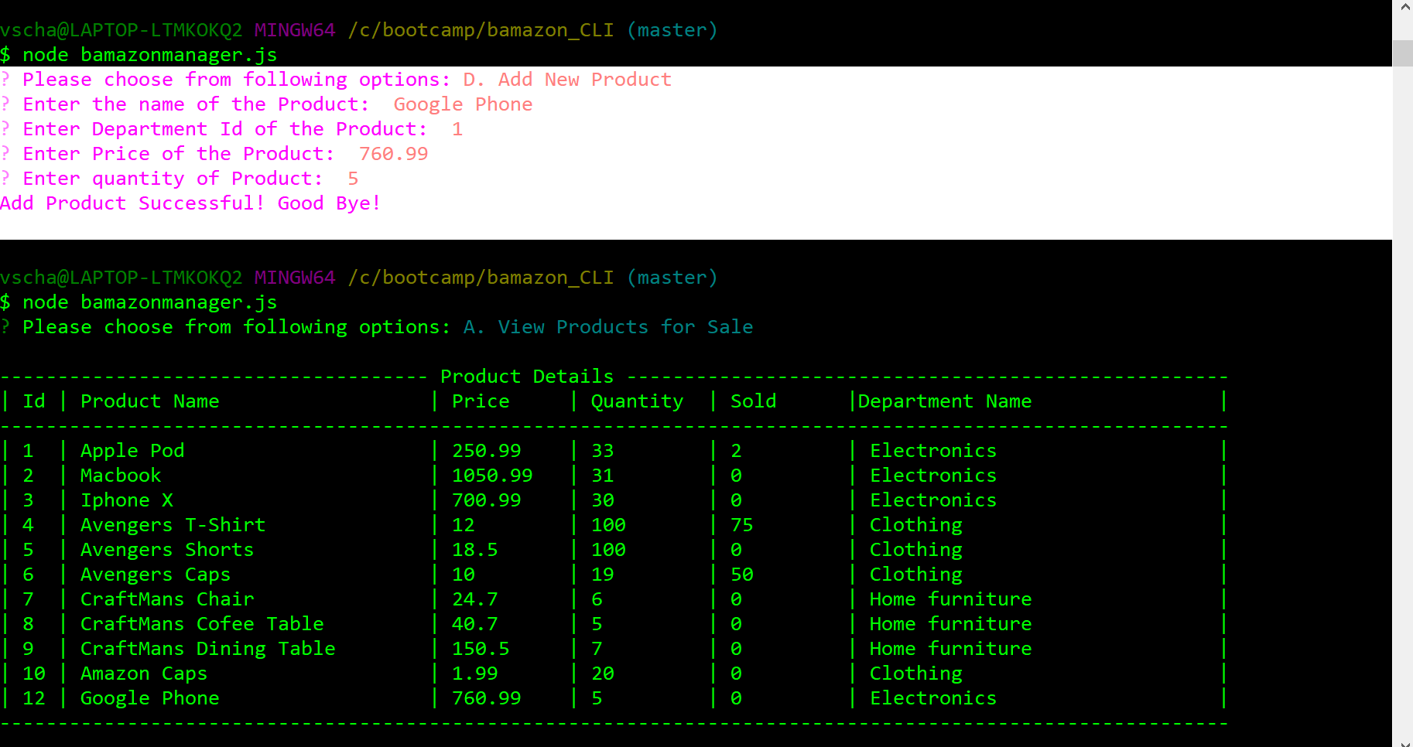

Superior View:

-> On running bamazonsuperior.js, shows various options

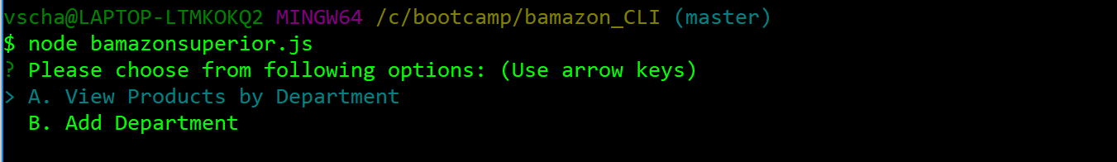

-> on selecting option.A, shows the all items sold by department with their profit ( overhead - total sales) - As asked , the profit is not stored in DB but calculated.

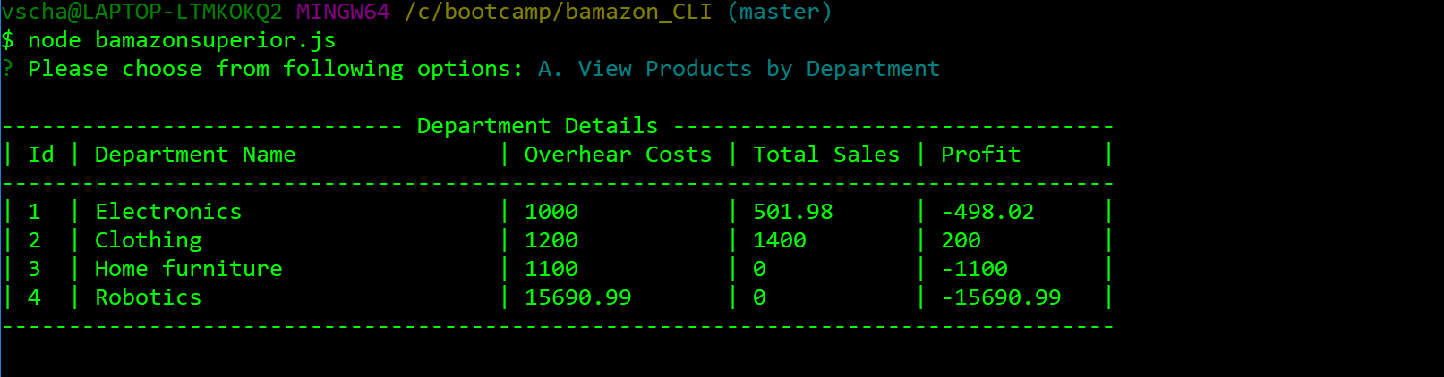

-> on selecting option.B, we can insert new department . In the example below, I have added “FineArts” with overhead of 4500.00

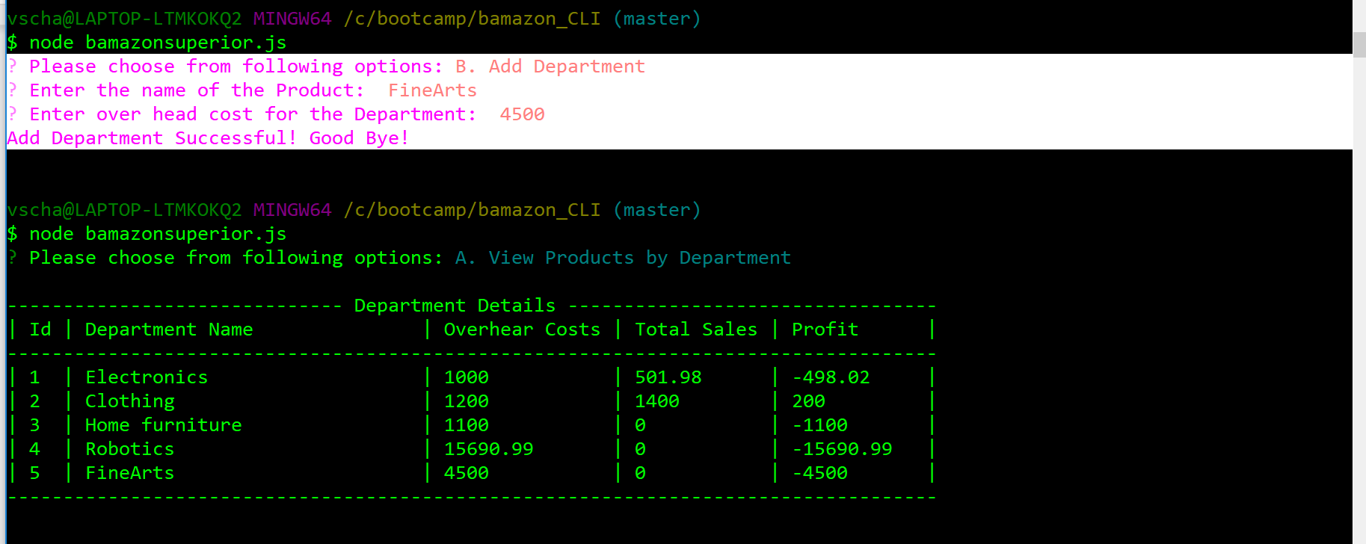

PS : Also most of error handling is coded to handle zeroes , non spaces etc.